**OUTPUT:**

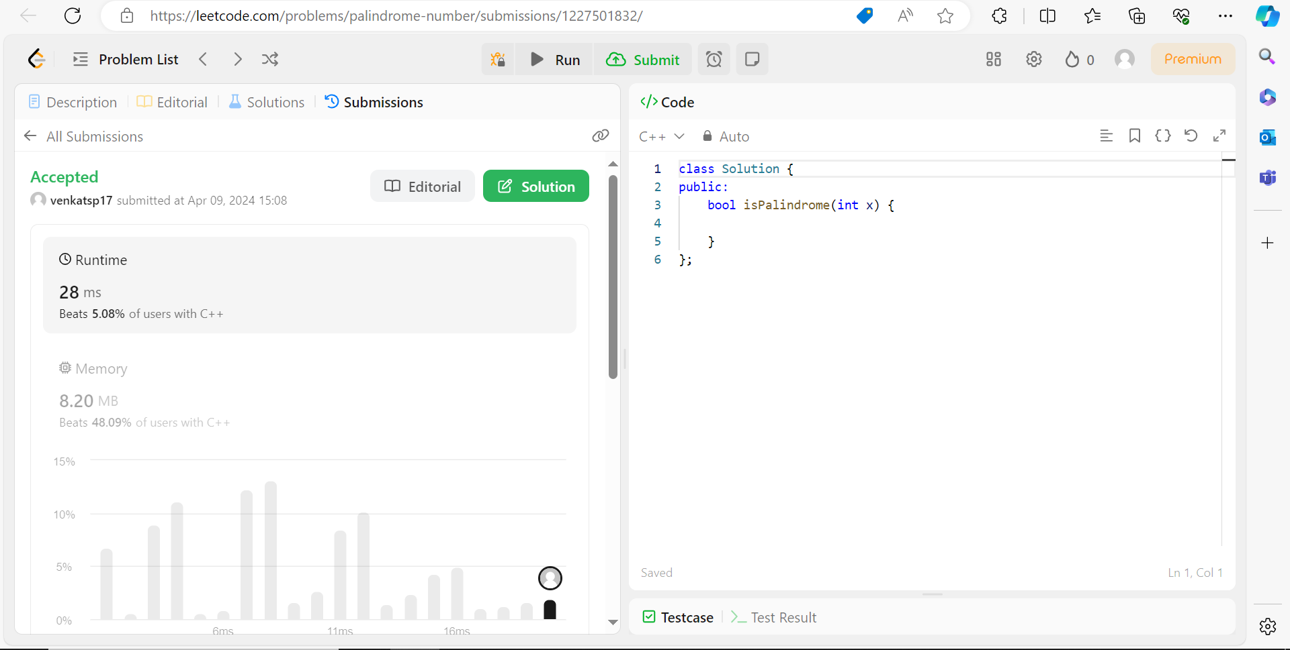

**CODE:**

class Solution {

public:

bool isPalindrome(int x) {

long long num=0;

long long y=x;

while(x>0){

int last_digit = x%10;

num = num*10 + last_digit;

x = x / 10;

cout<<num<<" ";

}

if(num==y){

return true;

}

else{

return false;

}

}

};